BC Calendar
# Source: AI Source: Provided by: [Data Path: Persons Table -> ID Column: 1, Name_En Column: Motasem Essam] -> From: [ChatGPT] on [7/17/2026]
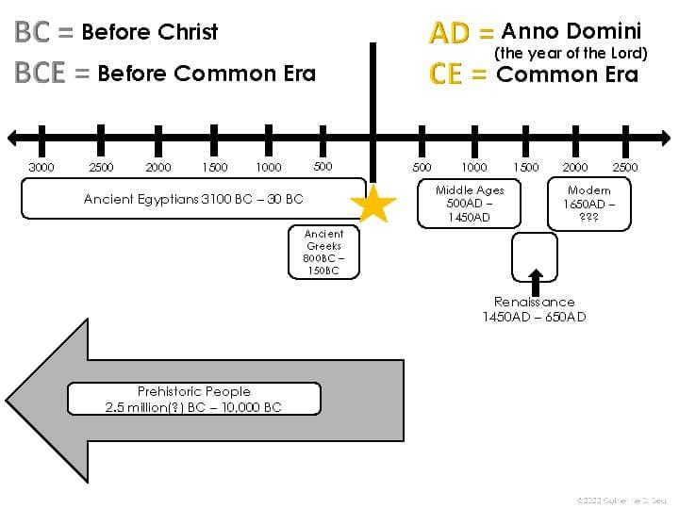
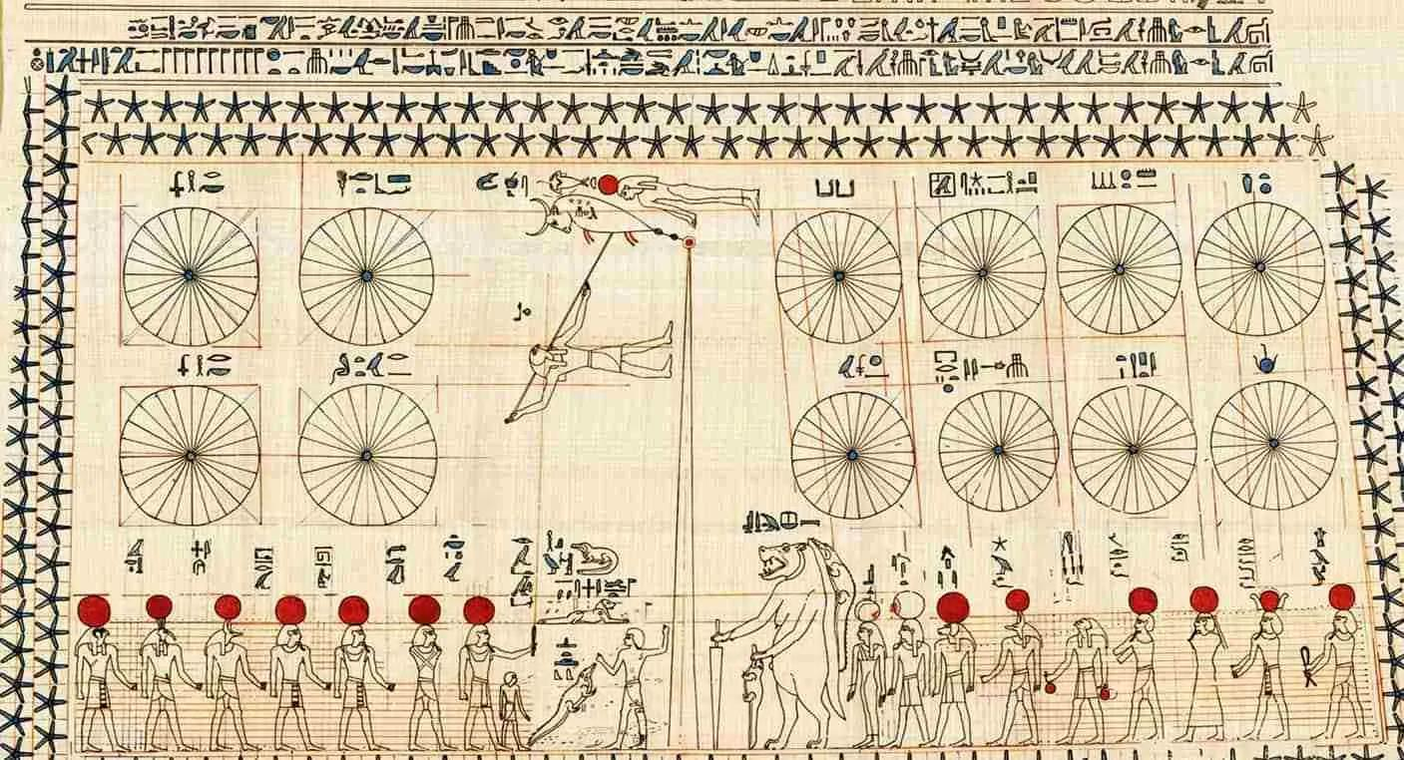
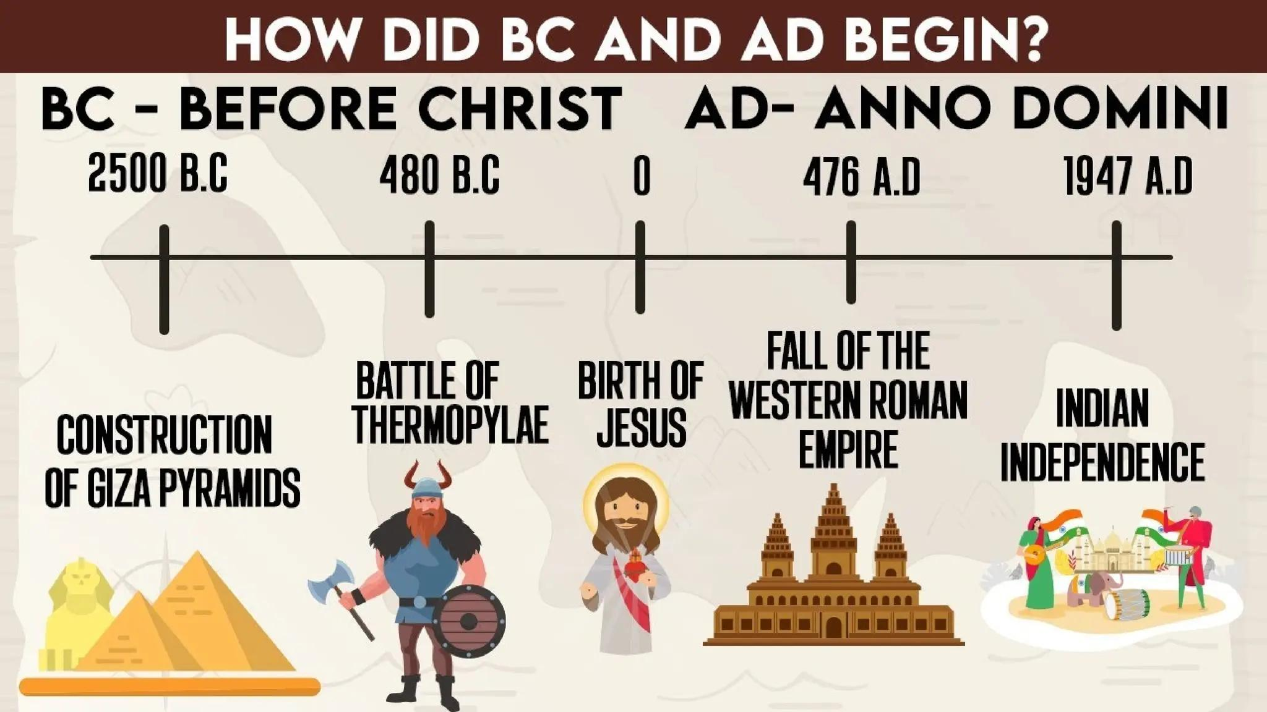
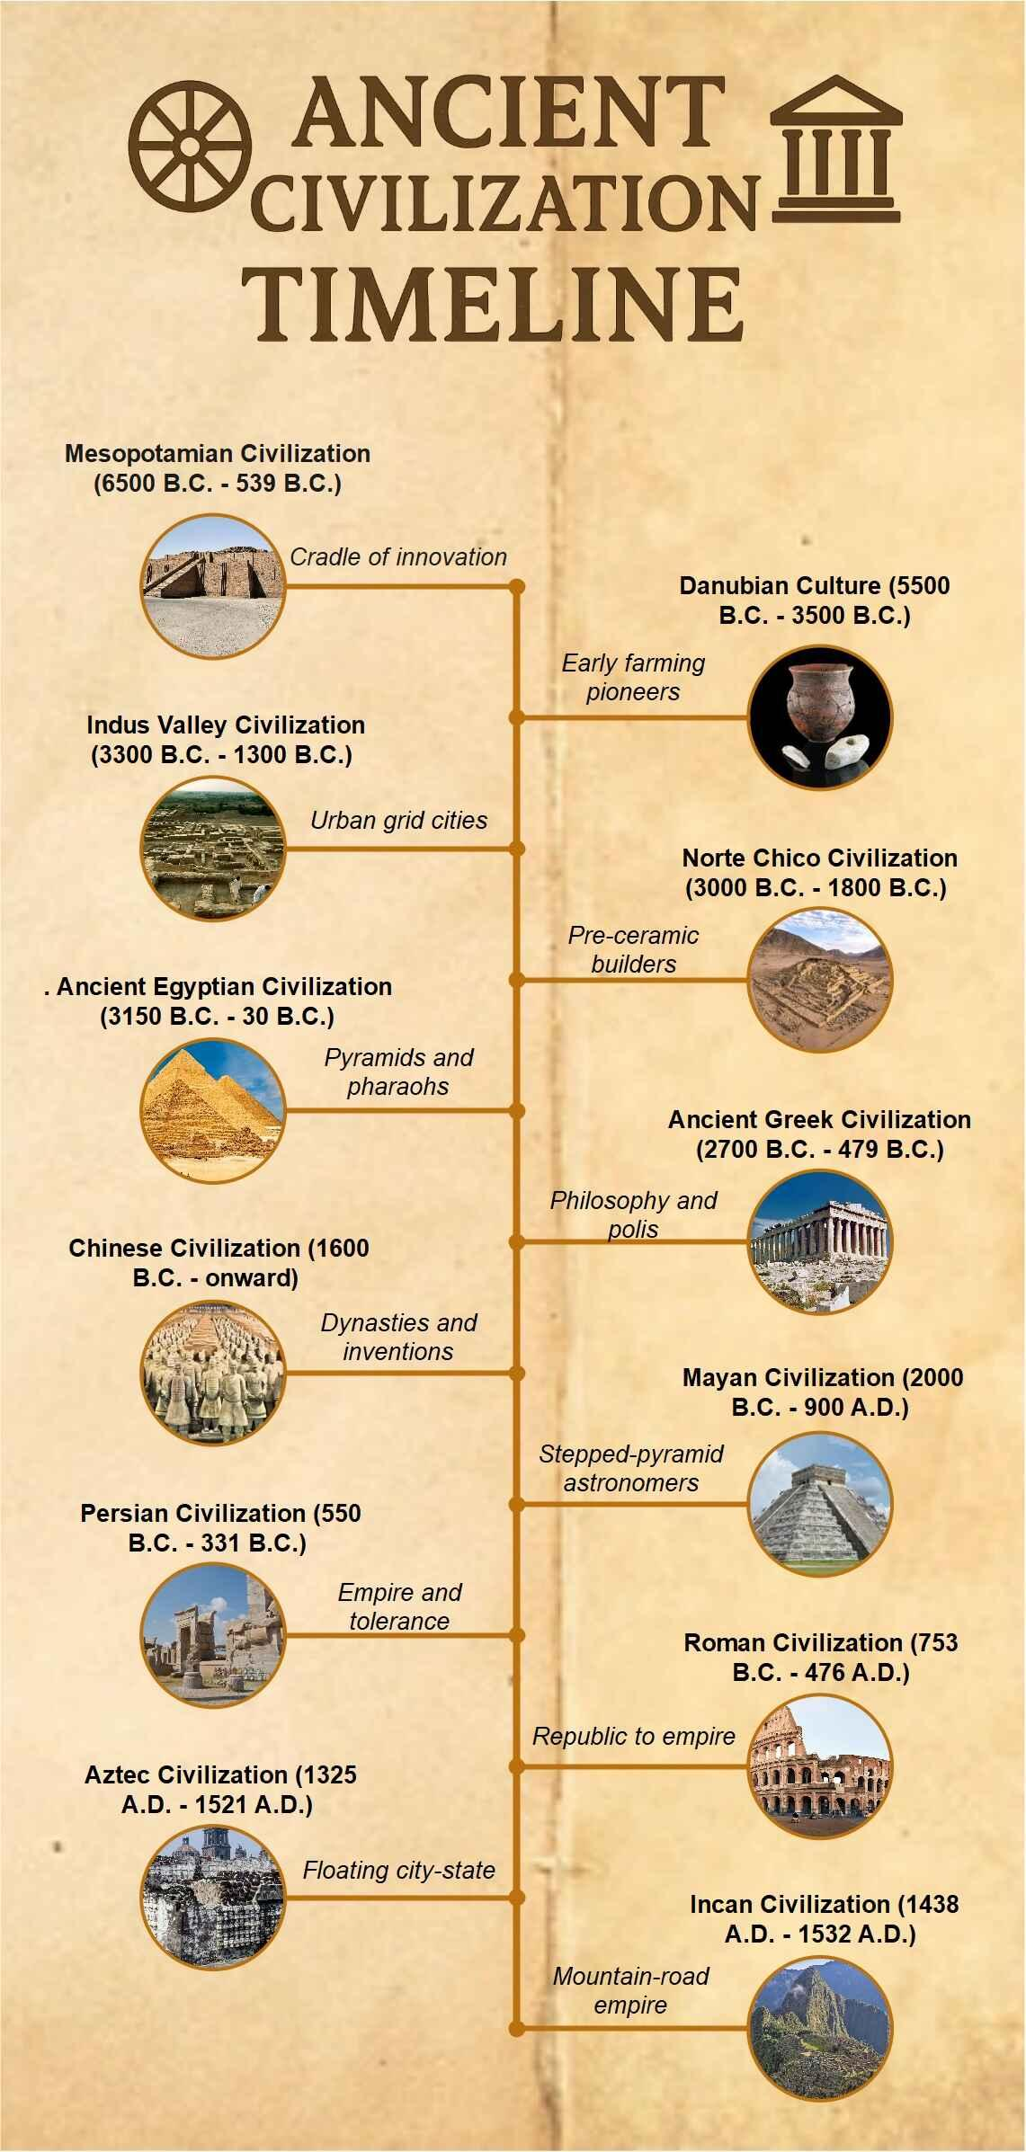
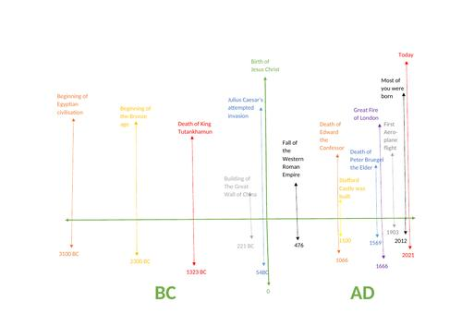
The BC Calendar (Before Christ) is the traditional system used to designate years before the birth of Jesus Christ in the Gregorian and Julian calendar systems. It is part of the BC/AD dating system and is commonly used in history, archaeology, and religious studies.
Today, many academic and international publications use the equivalent secular term BCE (Before Common Era) instead of BC, while keeping the same year numbers.

Definition
# Source: AI Source: Provided by: [Data Path: Persons Table -> ID Column: 1, Name_En Column: Motasem Essam] -> From: [ChatGPT] on [7/17/2026]
BC (Before Christ) is the traditional designation for years that occurred before the traditional birth year of Jesus Christ.

Meaning of BC
# Source: AI Source: Provided by: [Data Path: Persons Table -> ID Column: 1, Name_En Column: Motasem Essam] -> From: [ChatGPT] on [7/17/2026]
BC stands for:
Before Christ
It indicates years that occurred before AD 1.
Examples:
- 500 BC
- 300 BC
- 44 BC
- 1 BC

Historical Background
# Source: AI Source: Provided by: [Data Path: Persons Table -> ID Column: 1, Name_En Column: Motasem Essam] -> From: [ChatGPT] on [7/17/2026]
The BC/AD dating system was introduced by Dionysius Exiguus in the 6th century.
- AD (Anno Domini) was introduced first.
- The use of BC for earlier years became common several centuries later as historians extended the chronology backward.

How the BC Calendar Works
# Source: AI Source: Provided by: [Data Path: Persons Table -> ID Column: 1, Name_En Column: Motasem Essam] -> From: [ChatGPT] on [7/17/2026]
Years are counted backward as they approach the beginning of the Common Era.
Example sequence:
500 BC → 300 BC → 100 BC → 10 BC → 2 BC → 1 BC → AD 1 → AD 2
Notice that:
- There is no Year 0.

No Year Zero
# Source: AI Source: Provided by: [Data Path: Persons Table -> ID Column: 1, Name_En Column: Motasem Essam] -> From: [ChatGPT] on [7/17/2026]
The BC/AD system moves directly from:
- 1 BC
- AD 1
There is no Year 0.
This is important in:
- Historical chronology
- Astronomy
- Mathematics
Astronomers sometimes use a separate numbering system that includes Year 0, but the traditional BC/AD system does not.

Relationship to BCE
# Source: AI Source: Provided by: [Data Path: Persons Table -> ID Column: 1, Name_En Column: Motasem Essam] -> From: [ChatGPT] on [7/17/2026]
The BC system is numerically identical to the BCE system.
Traditional | Modern Equivalent
BC | BCE
Examples:
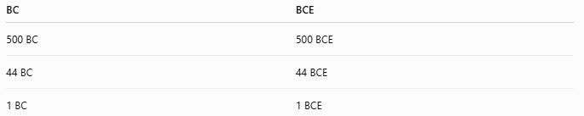
BC | BCE
500 BC | 500 BCE
44 BC | 44 BCE
1 BC | 1 BCE
Only the terminology differs.

Calendar Used
# Source: AI Source: Provided by: [Data Path: Persons Table -> ID Column: 1, Name_En Column: Motasem Essam] -> From: [ChatGPT] on [7/17/2026]
BC dates are most commonly expressed using:
- Gregorian Calendar (modern historical reference)
- Julian Calendar (for periods before the Gregorian reform)
When discussing ancient history, historians often specify which calendar convention is being used.

Applications
# Source: AI Source: Provided by: [Data Path: Persons Table -> ID Column: 1, Name_En Column: Motasem Essam] -> From: [ChatGPT] on [7/17/2026]
BC dates are commonly used in:
- Ancient history
- Archaeology
- Religious studies
- Classical civilizations
- Historical timelines
- Museums
- Academic research

Examples
# Source: AI Source: Provided by: [Data Path: Persons Table -> ID Column: 1, Name_En Column: Motasem Essam] -> From: [ChatGPT] on [7/17/2026]
Examples of well-known BC dates:
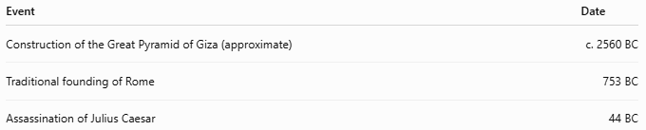
Event | Date
Construction of the Great Pyramid of Giza (approximate) | c. 2560 BC
Traditional founding of Rome | 753 BC
Assassination of Julius Caesar | 44 BC

Advantages
# Source: AI Source: Provided by: [Data Path: Persons Table -> ID Column: 1, Name_En Column: Motasem Essam] -> From: [ChatGPT] on [7/17/2026]
The BC system:
- Provides a clear chronological framework for ancient history.
- Has been widely used for centuries.
- Is compatible with the AD year-numbering system.

Limitations
# Source: AI Source: Provided by: [Data Path: Persons Table -> ID Column: 1, Name_En Column: Motasem Essam] -> From: [ChatGPT] on [7/17/2026]
- The designation "Before Christ" reflects Christian tradition.
- Many academic publications now prefer BCE because it is religiously neutral.
- There is no Year 0, which can complicate certain chronological calculations.

Common Mistakes
# Source: AI Source: Provided by: [Data Path: Persons Table -> ID Column: 1, Name_En Column: Motasem Essam] -> From: [ChatGPT] on [7/17/2026]
- Assuming BC years count forward.
They actually count backward toward AD 1.
- Believing there is a Year 0.
- Confusing BC with BCE.
They represent the same years.

Interesting Facts
# Source: AI Source: Provided by: [Data Path: Persons Table -> ID Column: 1, Name_En Column: Motasem Essam] -> From: [ChatGPT] on [7/17/2026]
- The year 44 BC is famous as the year of the assassination of Julius Caesar.
- Many ancient civilizations, including Egypt, Greece, and Rome, are studied using BC dates.
- Modern historians often use BCE instead of BC, but the numerical chronology remains unchanged.

Comparison with Other Year Numbering Systems
# Source: AI Source: Provided by: [Data Path: Persons Table -> ID Column: 1, Name_En Column: Motasem Essam] -> From: [ChatGPT] on [7/17/2026]
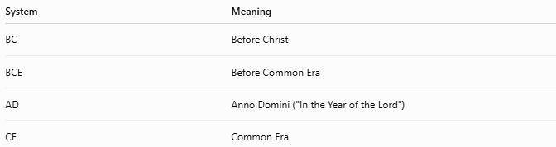
System | Meaning
BC | Before Christ
BCE | Before Common Era
AD | Anno Domini ("In the Year of the Lord")
CE | Common Era

Key Points
# Source: AI Source: Provided by: [Data Path: Persons Table -> ID Column: 1, Name_En Column: Motasem Essam] -> From: [ChatGPT] on [7/17/2026]
- BC stands for Before Christ.
- It identifies years before AD 1.
- BC years count backward toward AD 1.
- There is no Year 0.
- BC and BCE use identical year numbers.

Conclusion
# Source: AI Source: Provided by: [Data Path: Persons Table -> ID Column: 1, Name_En Column: Motasem Essam] -> From: [ChatGPT] on [7/17/2026]
The BC Calendar (Before Christ) is the traditional year-numbering system used to identify years before the beginning of the Common Era. It forms one half of the historical BC/AD chronology and has long been used to date events in ancient history. Although many modern academic works now use the equivalent BCE (Before Common Era) notation for neutrality, both systems represent the same chronological sequence and differ only in terminology.

